**DTC MainScreen Layout**

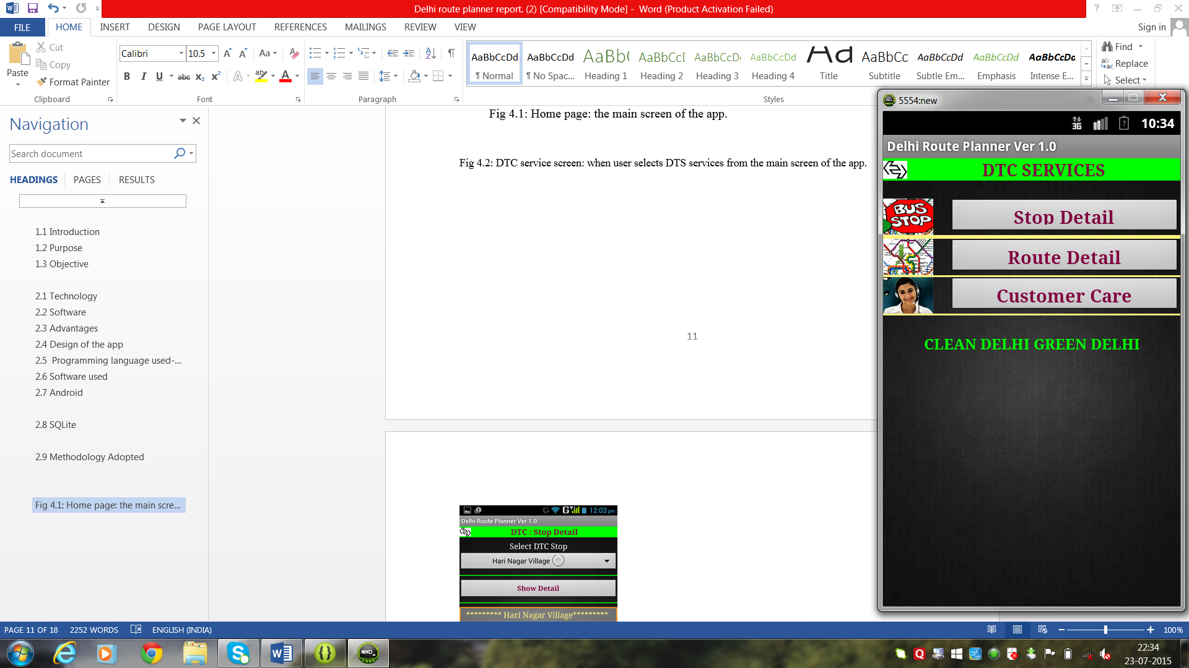

**Fig 1: DTC service screen: when user selects DTS services from the main screen of the app.**